Organic Chemistry

Select the alternative that correctly answers the following questions.

1. What is the bonding capacity of carbon? (how many covalent bonds can a carbon atom form)

a) 1 b) 2
c) 3 d) 4

2. What is an unsaturated hydrocarbon?

a) A hydrocarbon which contains only single carbon – carbon bonds.
b) A hydrocarbon which contains at least one double or triple carbon – carbon bond.
c) An alkane.
d) A hydrocarbon which only contains one carbon atom per molecule.

3. Which ONE of the following is an alkane?

a) C₂H₄
b) C₃H₆
c) C₃H₈
d) C₂H₂

4. What is the name of the following compound?

CH₃ CH CH₂ CH₃

CH₃

a) pentane
b) methylbutane
c) ethylpropane
d) dimethylpropane

5. The general formula for an alkene is

a) C_{n}H_{n}
b) C_{n}H_{2n}
c) C_{n}H_{2n+2}
d) C_{n}H_{2n-2}

6. Which alternative in the table below shows the correct classification of the substances, CH₄, C₂H₂, C₃H₈, C₃H₆, C₅H₈ and C₅H₁₀ as ALKANES, ALKENES or ALKYNES?

 | ALKANES | ALKENES | ALKYNES
a) | C₃H₆, C₅H₁₀ | CH₄, C₃H₈ | C₂H₂, C₅H₈
b) | CH₄, C₃H₈ | C₂H₂, C₅H₈ | C₃H₆, C₅H₁₀
c) | CH₄, C₃H₆ | C₂H₂, C₅H₁₀ | C₅H₈, C₃H₈
d) | CH₄, C₃H₈ | C₃H₆, C₅H₁₀ | C₂H₂, C₅H₈

7. Organic compounds which have the same molecular formula but different structural formulas are known as

a) isotopes.
b) homologous compounds.
c) isomers.
d) polymers.

8. How many structural isomers are there with molecular formula C₅H₁₂?

- 2
- 3
- 4
- 5

9. What is the correct name for the compound represented by the structural formula below?

CH₃ CH₃

CH₃ CH CH CH₃

a) 2,3-dimethylbutane
b) dimethylbutane
c) 2,3,3-trimethylpropane
d) ethylbutane

10. What is the correct name of the compound represented by the structural formula shown below?

CH₃ CH CH CH₃

CH₃

a) 2-methyl-3-butene
b) pentene
c) 3-methyl-1-butene
d) methylbutyne

11. Which one of the following shows the structural formula of 4-methyl-2-pentyne?

a) CH₃

CH C CH₂ CH CH₃

b) CH₃ C C CH₂ CH₂

CH₃

c) CH₃

CH₃ C C CH CH₃

d) CH₃

CH C CH CH₂ CH₃

12. The structural formula below is for a compound known as:
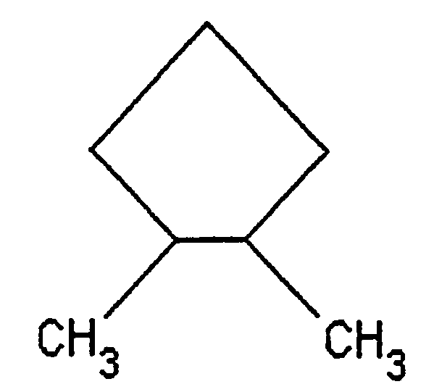

a) 1,2-dimethylcyclopentane
b) 4,5-dimethylcyclopentane
c) cyclohexane
d) benzene
13. The products formed from the complete combustion of hydrocarbons are

a) carbon monoxide and water.
b) carbon monoxide and hydrogen
c) carbon dioxide and water.
d) carbon dioxide and hydrogen.

14. The main component of natural gas is

a) methane
b) ethane
c) propane
d) butane

15. Which of the following shows the correct equation for the complete combustion of octane?

a) C₈H₁₈ + ¹⁷/₂O₂ 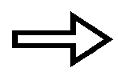 8CO + 9H₂O
b) C₈H₁₈ + ²⁵/₂O₂ 8CO₂ + 9H₂O
c) C₈H₁₈ + ⁹/₂O₂ 8C + 9H₂O
d) C₈H₁₈ + 8O₂ 8CO₂ + 9H₂

16. In the presence of ultraviolet light, the following reaction will occur between methane and chlorine.

CH₄(g) + Cl₂(g) CH₃Cl(g) + HCl(g)

This type of reaction is called

a) an addition reaction.
b) a subtraction reaction.
c) a substitution reaction.
d) a hydrogenation reaction.

17. Consider the statements below describing what may happen when a sample of hexene is added to an aqueous solution containing bromine.

I. The solution becomes very hot.
II. The solution remains red due to the presence of bromine.
III. The red colour of the solution will fade due to the bromine being consumed.
IV. A pungent smelling gas is produced which turns blue litmus paper, red.

17. [cont’d] Which of the above statement/s is/are true?

a) I only.
b) III only.
c) II and IV.
d) III and IV.

18. Which equation below shows what happens in the reaction which occurs in question 17? .

a) C₆H₁₂(l) + 2Br₂(l) C₆H₁₀Br₄(l) + H₂(g)
b) C₆H₁₂(l) + Br₂(l) C₆H₁₂Br₂(l)
c) C₆H₁₂(l) + 3Br₂(l) C₆H₆Br₆(l) + 3H₂(g)
d) C₆H₁₂(l) + 2Br₂(l) C₆H₁₂Br₄(l)

19. The type of reaction which occurs between hexene and bromine is called.

a) a halogen substitution reaction.
b) an addition reaction.
c) a neutralisation reaction.
d) an oxidation – reduction reaction.

20. Which of the following substances would react most readily with bromine? .

a) Methane.
b) Ethane.
c) Ethene.
d) 1,2-dibromoethane.

The next two questions refer to the information below.

A student has two solutions containing organic compounds, A and B. He carries out the following tests to try to identify the solutions.

Compound A is mixed with liquid bromine in water and shaken. There is an immediate decolourisation of the red bromine solution.
When the same test is carried out on compound B, the red bromine solution decolourises very slowly and after a while, pungent acid fumes are detected.

21. Compound A could be

a) methane
b) ethane
c) ethene
d) 1,2-dichloroethane

22. Compound B could be .

a) ethane
b) ethene
c) cis-2-butene
d) trans-2-butene

23. Study the structural formulas and statements below:

H H

Compound 1 C C

Cl Cl

Cl H

Compound 2 C C

H Cl

I. Compound (1) is known as cis-1,2-dichloroethene and compound (2) is known as trans-1,2-dichloroethene.
II. Both compounds are called 1,2-dichloroethene.
III. Compounds (1) and (2) are geometric isomers.
IV. Compound (1) is known as trans-1,2-dichloroethene and compound (2) is known as cis-1,2-dichloroethene.
V. These compounds will have different melting and boiling points.
VI. The two compounds would have identical physical and chemical properties.

The correct statements are

a) II, III and VI.
b) I, III and V.
c) I, III and VI.
d) III, IV and VI.
24. The name of the compound represented by the structure below is:

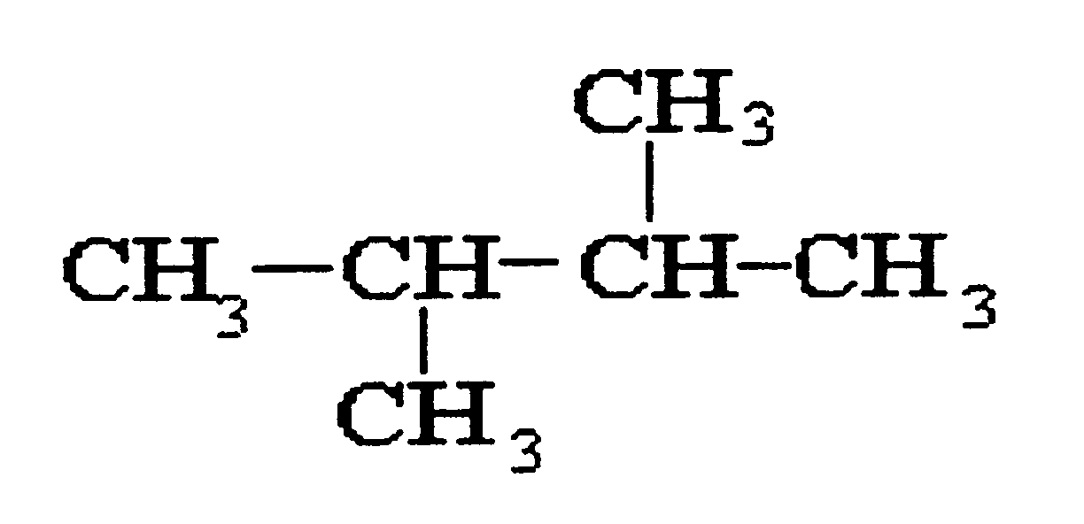
a) trans-butane.
b) 2,3–dimethylbutane.
c) hexane.
d) 2-methylpentane.

25. Which one of the following is an alkane?

a) C₅H₁₂
b) C₂H₄
c) C₄H₆
d) C₇H₁₄

26. The type of reaction which occurs between chlorine and ethane, C₂H₆ is called

a) an addition reaction.
b) a substitution reaction.
c) a hydrolysis reaction.
d) a hydrogenation reaction.

27. How many isomers are possible with formula C₅H₁₂?

a) 2 b) 3
c) 4 d) 5

28. Which one of the following compounds is saturated?

a) CH₄
b) C₂H₄
c) C₂H₂
d) C₃H₆

29. Which one of the following would occur when acidified potassium dichromate is added to ethanol and gently heated?

a) The solution remains orange as there is no reaction.
b) The solution changes from orange to yellow.
c) The solution changes from orange to green.
d) The solution changes from orange to colorless.

30. The organic product formed in the reaction referred to in question 6 between ethanol and potassium dichromate is

a) Ethanal.
b) ethyl ethanoate.
c) potassium ethanoate.
d) Ethene.

31. Which one of the following is a secondary alcohol?

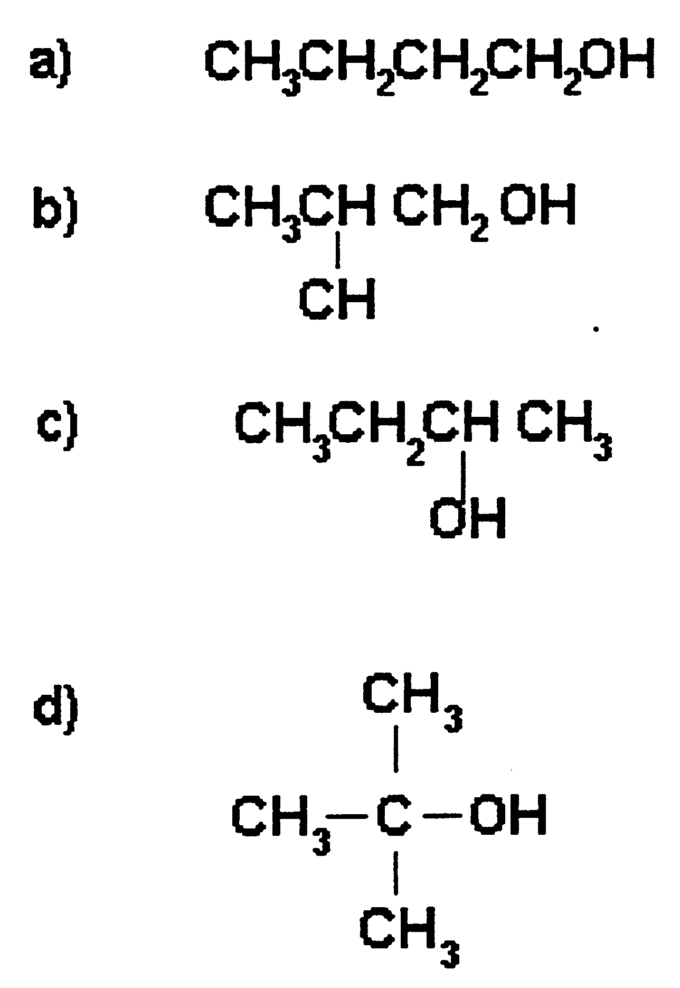

32. The product formed when a secondary alcohol is oxidised by permanganate ion is

a) an ester.
b) a carboxylic acid.
c) an ether.
d) a ketone.

33. Which one of the following alcohols is not oxidised by dichromate or permanganate ions?

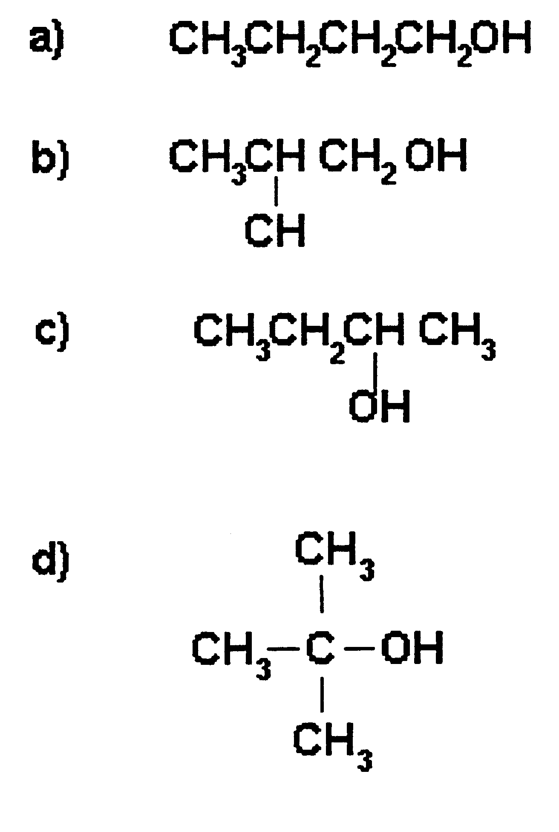

34. The least reactive alcohol listed below is

a) 1-butanol.
b) 2-methyl-1-propanol.
c) 2-butanol.
d) 2-methyl-2-propanol.

35. The reaction below shows the oxidation of an alcohol by permanganate ion:

5CH₃CHOHCH₃(aq) + 2MnO₄⁻(aq) + 6H⁺(aq) 5CH₃COCH₃(aq)
+ 2Mn²⁺(aq) + 8H₂O(l)

The name of the organic compound produced is

a) propanone.
b) methylethanoate.
c) ethoxymethane.
d) 2-propanal.

36. What two substances are used to produce ethyl butanoate?

a) Butanol and ethanoic acid.
b) Butanol and ethane.
c) Ethanol and butanoic acid.
d) Butane and ethanol.

37. Which one of the following is NOT a characteristic of esters?

a) They are good solvents.
b) They have a pleasant, ‘fruity’ odor.
c) They are readily oxidised by permanganate and dichromate ions.
d) They are liquids at room temperature.

38. A colorless organic liquid reacts with sodium, producing a colorless gas, which burns in the presence of oxygen with a ‘pop’. Addition of concentrated sulfuric acid to the organic compound evolves a colorless gas, which decolorises bromine water.
The organic compound described above could be

a) C₂H_{6.}
b) CH₃COCH₃
c) C₂H_{4.}
d) C₂H₅OH.

39. The name of the following ester, CH₃CH₂COOCH₂CH₃, is

a) ethyl butanoate.
b) methyl propanoate.
c) propyl ethanoate.
d) ethyl propanoate.

40. The formula of the ester, ethyl ethanoate is

a) CH₃COOCH₂CH₃
b) CH₃COCH₂CH₃
c) CH₃COOCH₃
d) CHCOOCH₂CH₃

41. Which one of the following represents an aromatic compound?

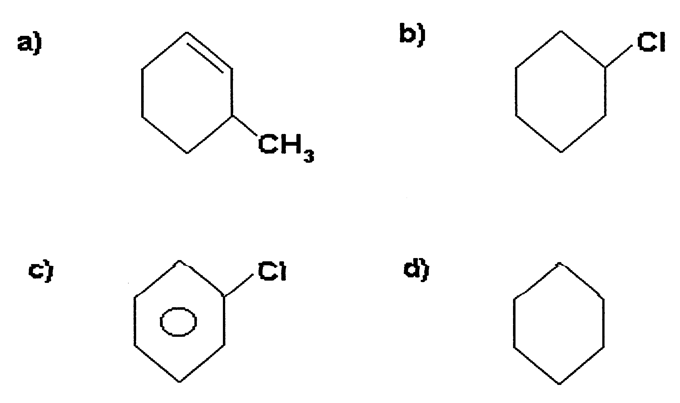

42. Substances which have the same molecular formula but a different structural formula are called

a) isotopes.
b) isomers.
c) hybrids.
d) a family.

43. Study the following structure and determine the functional groups present.

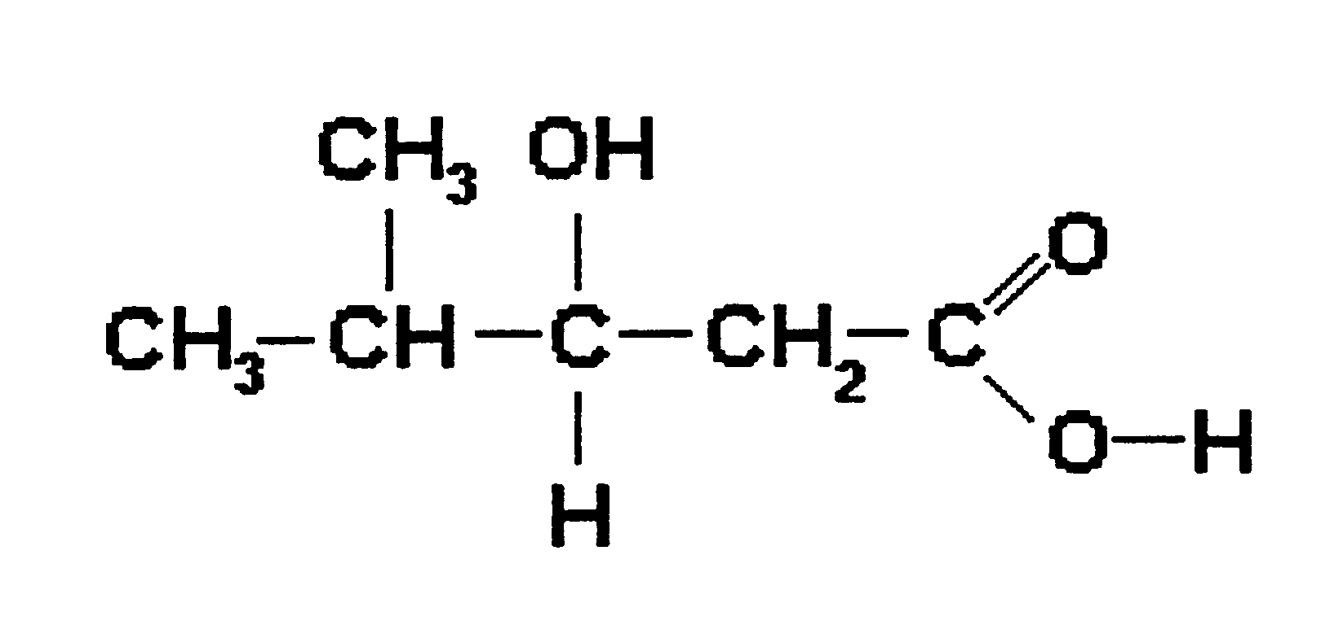
a) An alcohol and an ester.
b) An alcohol and a carboxylic acid.
c) A ketone and an aldehyde.
d) An alcohol and an aldehyde.

44. The diagram below shows ethene molecules joining to form a large chain molecule.

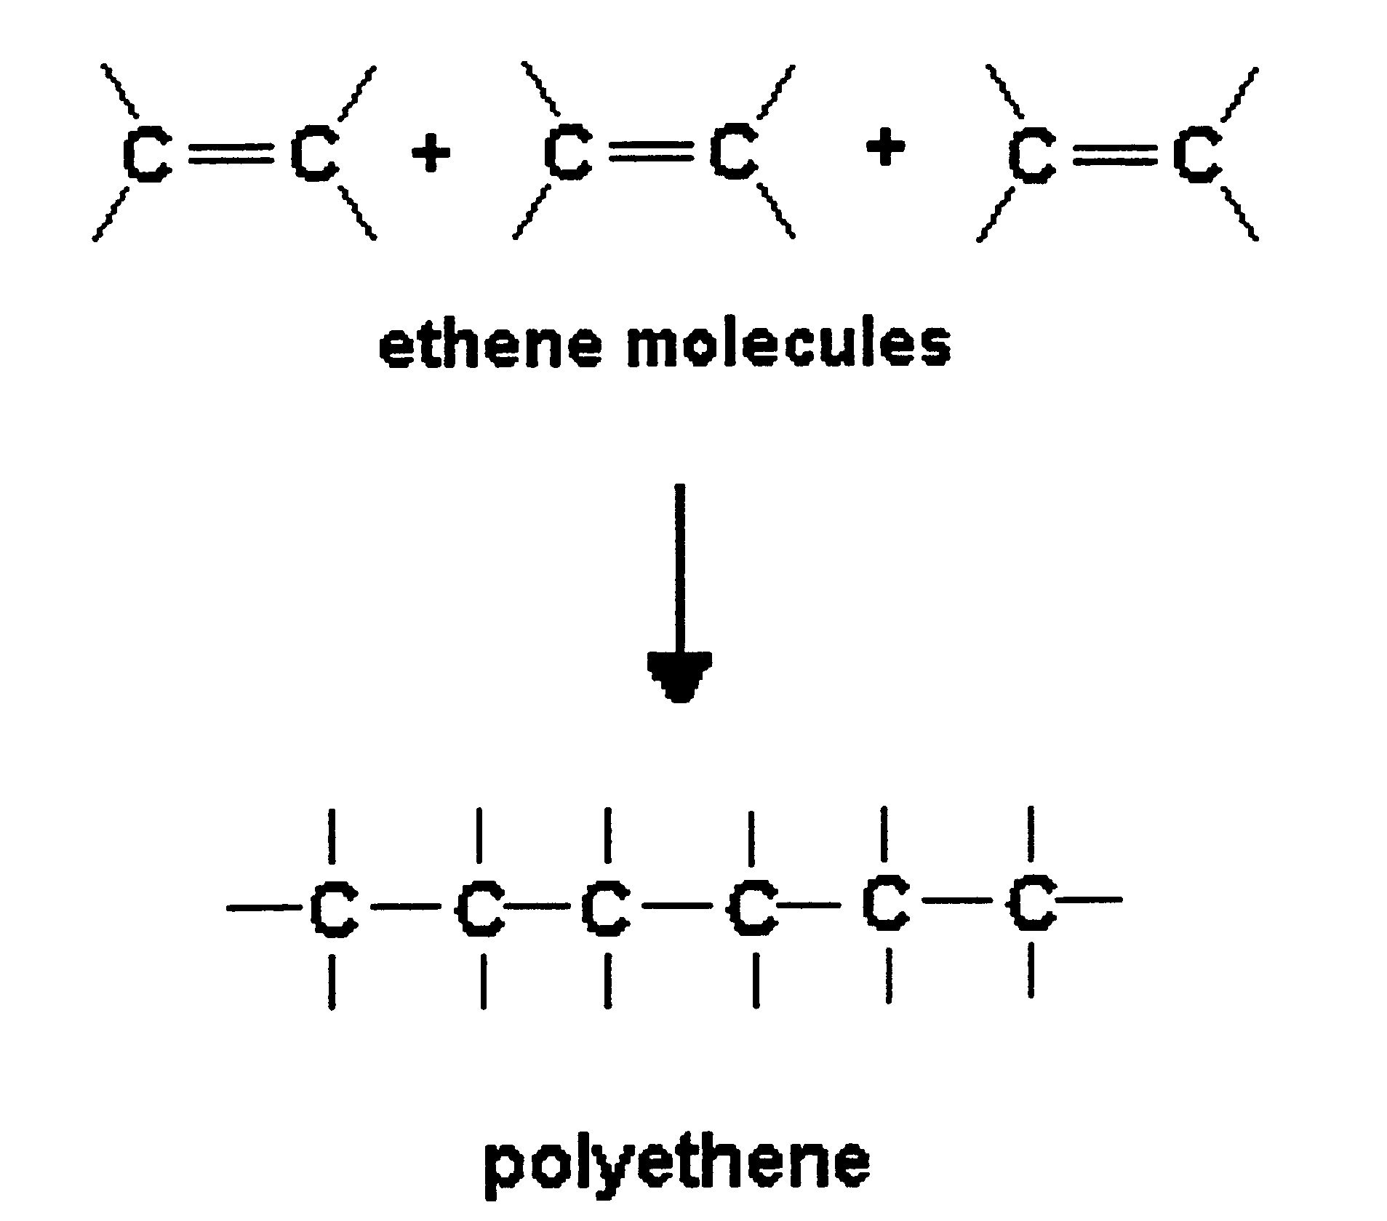

This type of reaction where ethene molecules form polythene is called

a) substitution.
b) hydrogenation.
c) addition polymerisation.
d) condensation polymerisation.

45. Which of the following is produced by condensation polymerisation?

a) Polychloroethene (PVC).
b) Polypropene.
c) Nylon.
d) Polyurethane.

46. Which one of the following reactions is NOT an addition reaction?

a) C₂H₂(g) + 2Cl₂(g) C₂H₂Cl₄(g)
b) C₃H₄(g) + 2H₂(g) C₃H₈(g)
c) CH₄(g) + 2Cl₂(g) CCl₄(g) + 2H₂(g)
d) C₂H₄(g) + Br₂(l) C₂H₄Br₂(g)

47. Which one of the following structures is cis-2,3-dichloro-2-butene?

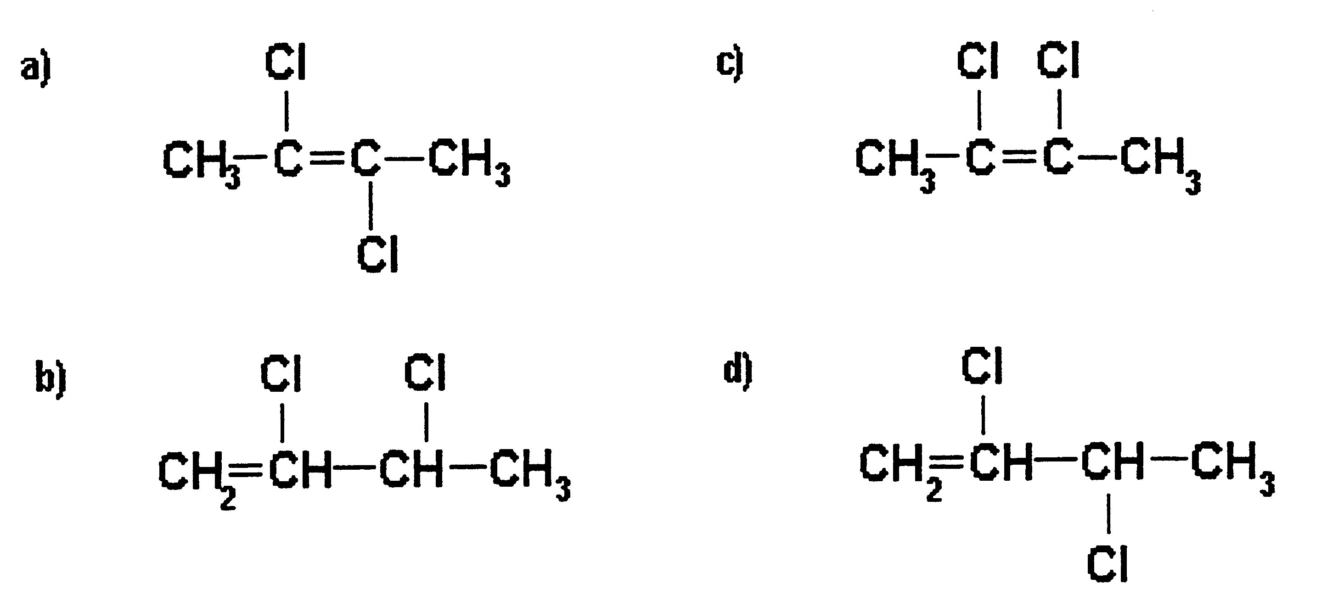

48. Which one of the following could not exist?

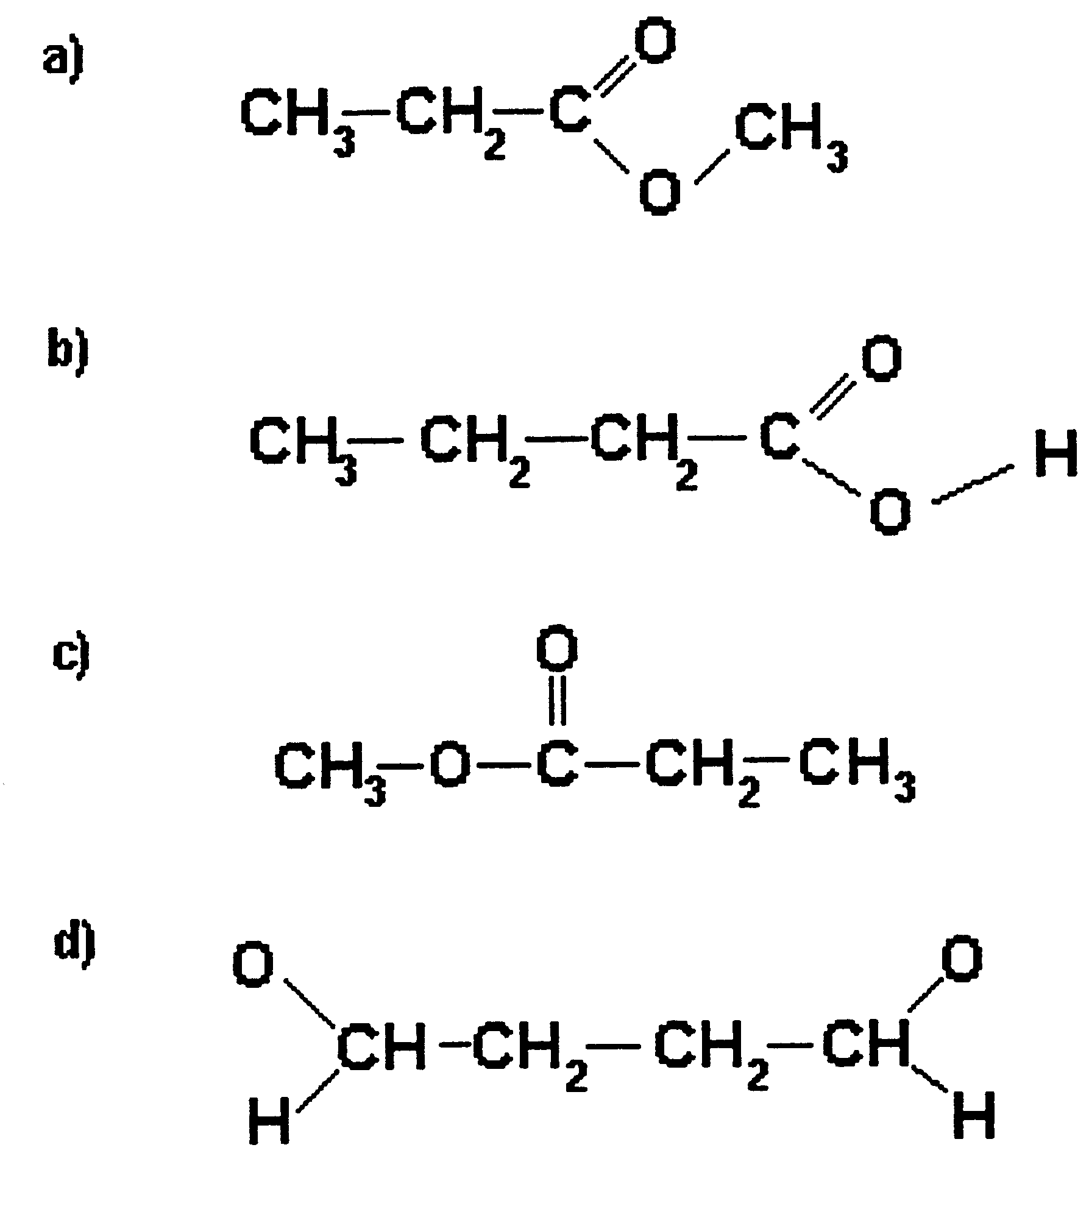

49. Which one of the following would most readily decolourise bromine water?

a) Ethane.
b) Ethene.
c) Ethyne.
d) Benzene.

50. CH₃CH₂OH + CH₃COOH CH₃COOCH₂CH₃ + H₂O

The reaction shown above is an example of

a) an acid-base reaction.
b) an addition reaction.
c) a substitution reaction.
d) an esterification reaction.

51. Which of the statements concerning the compound shown below is FALSE?

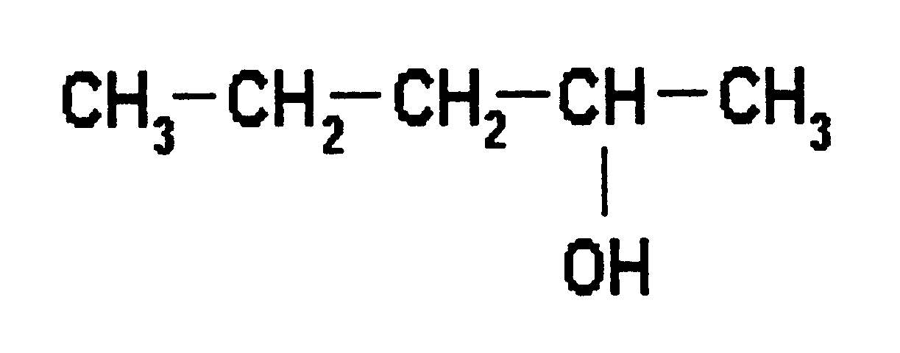
a) Its name is 2-pentanol.
b) It would be soluble in water.
c) It would be oxidised to form an aldehyde in the presence of dichromate ions in acid solution.
d) It would react slowly with sodium metal to produce hydrogen gas.

52. Which of the following is an aldehyde?

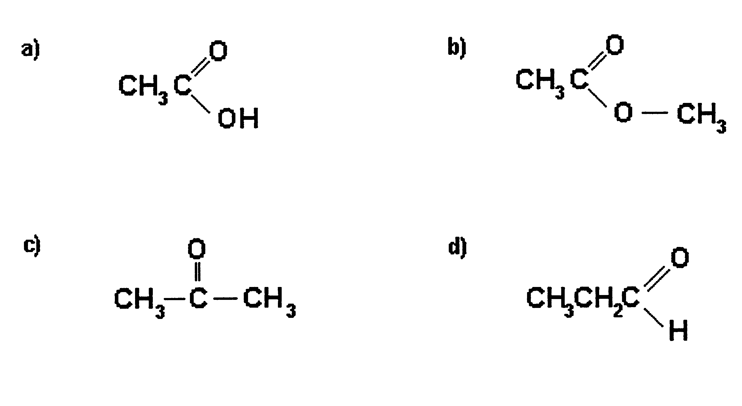

53. Which one of the following structures below represents methylbenzene?

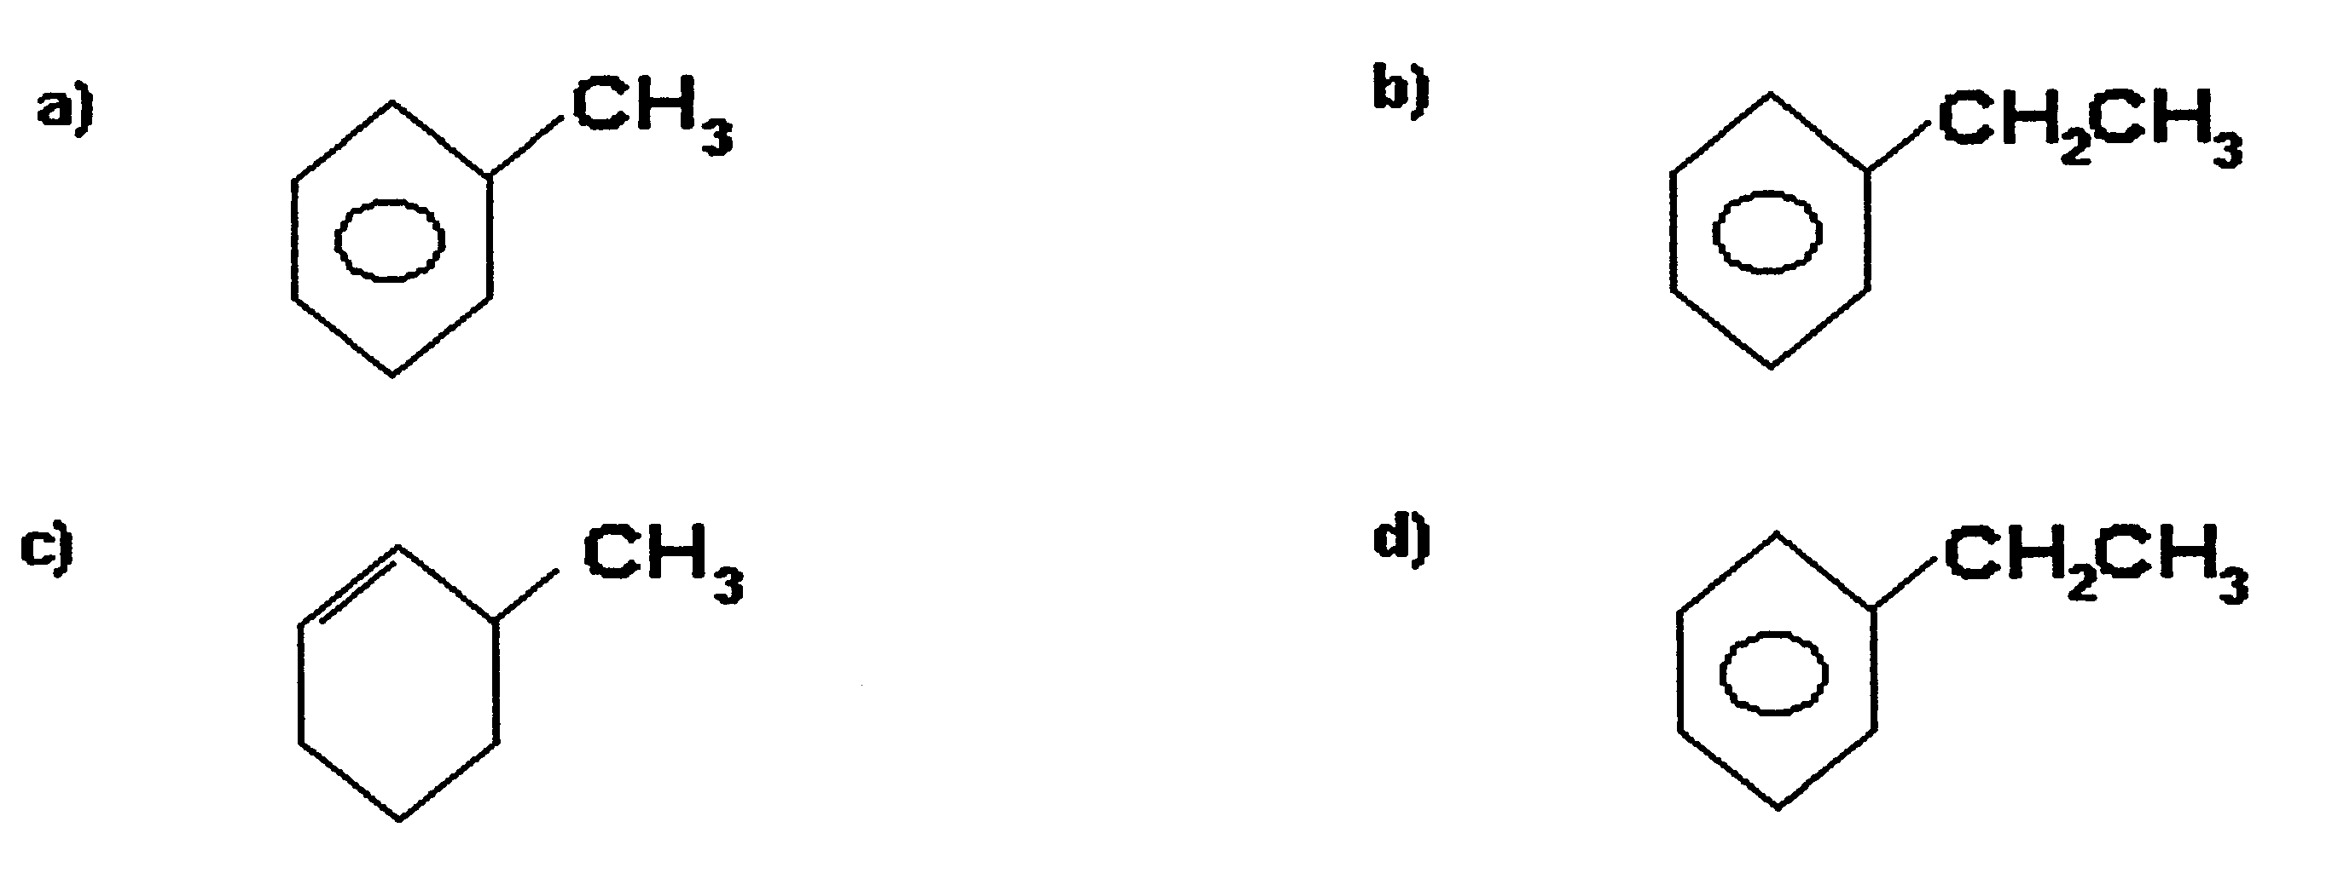

54. The reaction between an oil or fat and sodium hydroxide is called saponification and results in the production of

a) an ester.
b) a soap.
c) a carboxylic acid.
d) an amine.

55. A soap molecule can be thought of as a long organic chain joined to positive metal ions such as Na⁺ or K⁺. In aqueous solution, the soap molecules release the sodium ions and the large negatively charged organic ion.

RCOO⁻Na⁺(s) RCOO⁻(aq) + Na+(aq) Soap

What is the function of the organic ion component of the soap molecule in the cleaning process?

a) The uncharged end of the organic ion can dissolve both polar and non-polar substances.
b) The negatively charged end of the organic ion dissolves water soluble substances while the non-polar (uncharged end) dissolves non-polar substances such as oil and grease.
c) The non-polar end of the organic ion can dissolve polar substances while the charged end dissolves non-polar substances such as oil and grease.
d) It is the sodium ions in the soap molecules, which dissolves grease and oil molecules.

Study the table below and answer the next three questions.

CHEMICAL TEST
Compound | Addition of Na metal | Addition of aqueous bromine. (Br₂) | Addition of acidified KMnO₄.
X | No reaction | Colour of solution fades. | No reaction
Y | Solution bubbles vigorously, producing a colourless gas. | No reaction. | Solution becomes colourless and a ‘vinegary’ smell is noted.
Z | No reaction | No reaction | No reaction

56. Compound X is most likely to be

a) 1,2-dichloroethane.
b) hexene.
c) ethanol.
d) 2-methyl-2-propanol.

57. Compound Y is most likely to be

a) 1,2-dichloroethane.
b) hexene.
c) ethanol.
d) 2-methyl-2-propanol.

58. Compound Z is most likely to be

a) 1,2-dichloroethane.
b) hexene.
c) ethanol.
d) 2-methyl-2-propanol.

59. Which one of the following structures represents pentanamide?

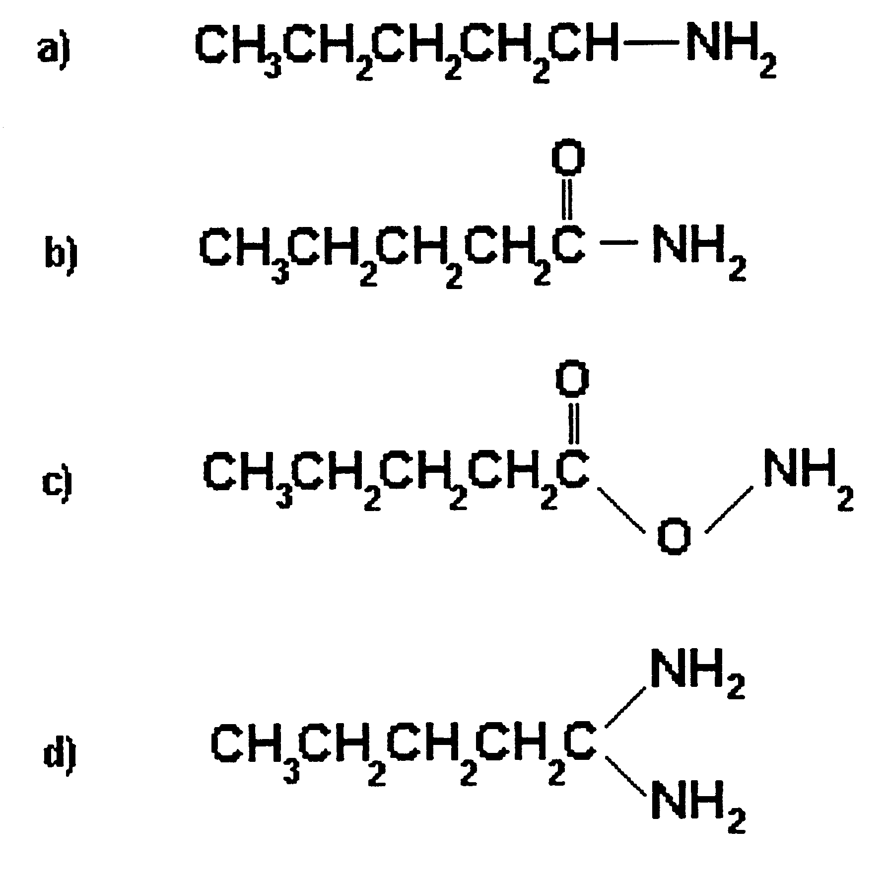

60. What is the name of the compound represented by the structure below?

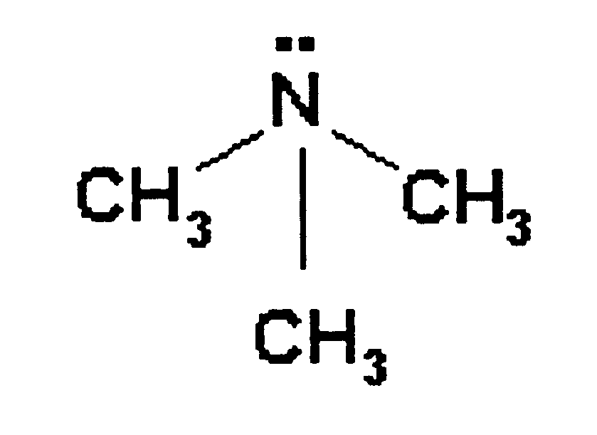

a) Propanamine.
b) 1,2,3-methyl amine.
c) Trimethyl amine.
d) 2-amine propane.

